CAPSTONE PROJECT

SHOPNEST STORE REPORT

**INTRODUCTION**: ShopNest stands as the leading department store in the e-commerce marketplaces in Portugal. Serving as a seamless link, it connects small businesses from various regions in Portugal to channels, streamlining the process with a single point of contact. Through the ShopNest Store, these merchants can showcase and sell their products, with the added convenience of direct shipment to customers facilitated by ShopNest logistics partners.

**OBJECTIVE**: The primary objective is to create a Shopnest dashboard to analyze the total revenue for the year. Additionally, it will analyze on-time and delayed orders of the store, which helps improve our delivery. I have also analyzed state-wise and seasonal sales patterns. The Shopnest store can gain deeper understanding of its customers and grow its sales and revenue for the next year.

First, I made sure to make a background in PowerPoint, including the title, and save it in scalable vector graphics format(.svg). This is the background I have made for this dashboard.

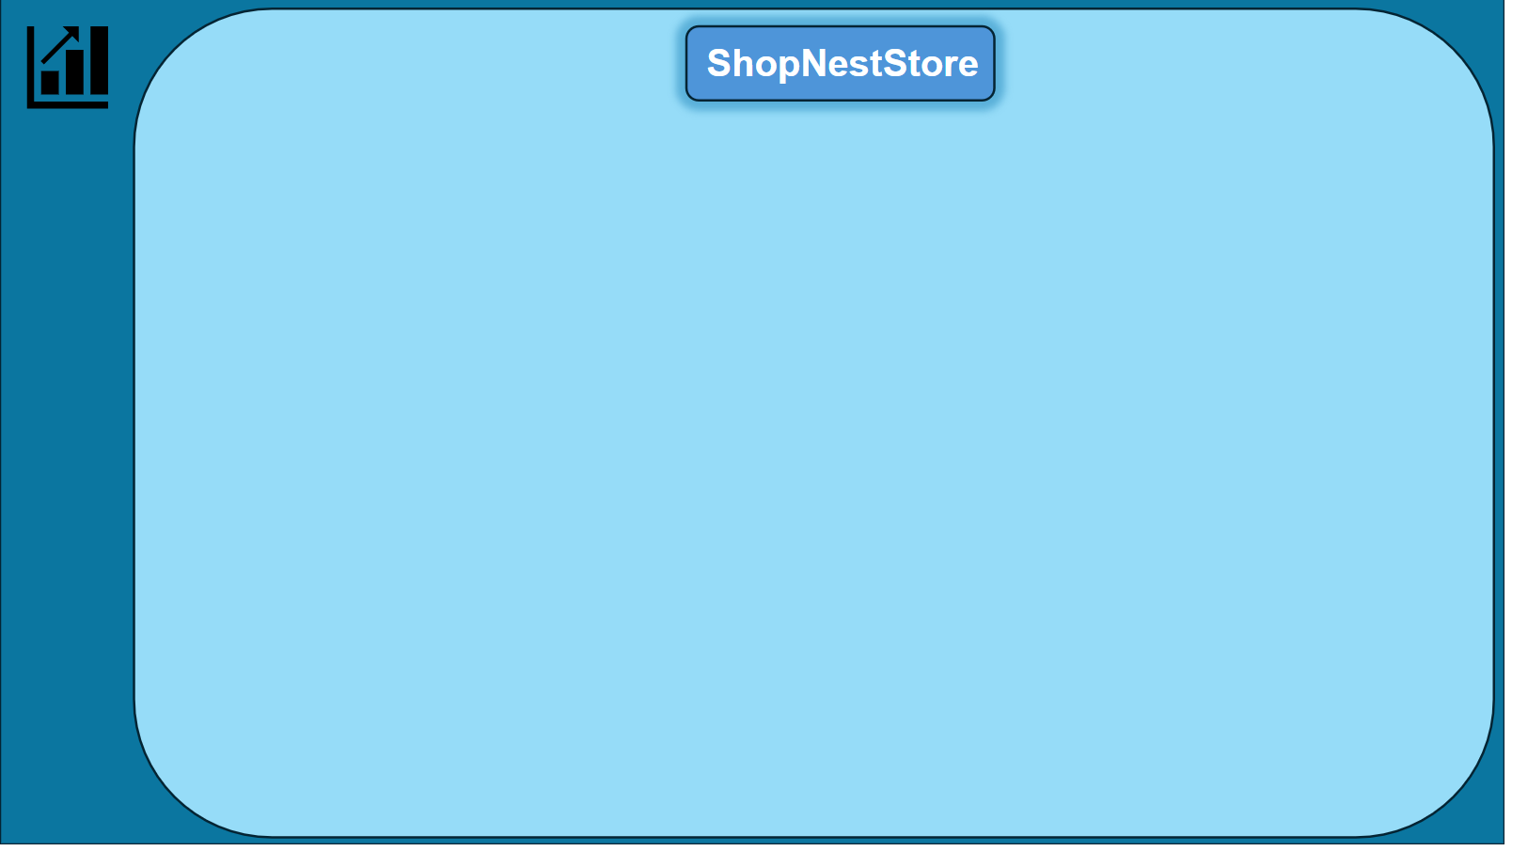

Then load it into the powerbi in the visualization tool.

We have all the data in Excel format after opening Power BI, press get data and select the Excel/CSV file, load all the tables into Power BI.

1. Data Cleaning - First, we need to clean the data and make sure that the data types align perfectly with the column.
2. Data Modelling - After cleaning the data and we need to go to the model view and make relationships with tables.

**Top Categories by Total Price:**

Identify and visually represent the top 10 product categories by total sales.

1. To calculate TotalSales, we need to create a measure which is Sum(‘order_items’[price]).
2. Add a visual, I have added column chart and

‘product_category_name_english’ on Y-axis and TotalSales on X-axis.

1. Go to the filters section under product_category_name_english expand and select the Top N filter, we need the top 10 products, so select ‘TOP’ and then enter the number ‘10’. Apply filter and then we will get required output.
2. Then change all the background colour, legend, title, Y-axis,X-axis according to your own choice.

**Delayed Orders Analysis:**

Determine the number of delayed orders in each category. An order is considered delayed if the actual delivery date is later than the estimated delivery date.

1. 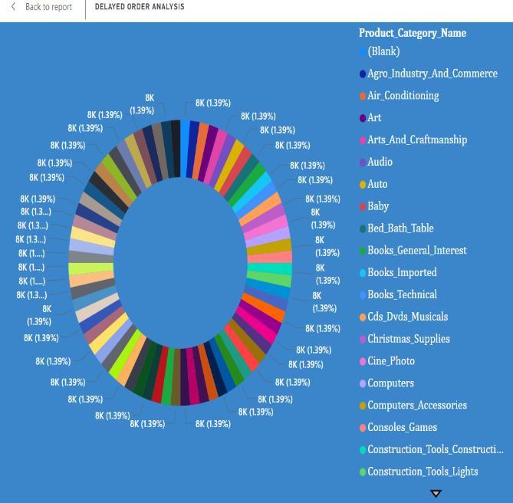Create a measure for this, where Orders[order_delivered_customer_date] > Orders[order_estimated_delivery_date]
2. Keep product_category_name_english on legend as I have taken a Donut chart.
3. Then, Delayed Orders on the values
4. Then change all the background colour, legend, title, Y-axis, X-axis according to your own choice.

**Monthly Comparison of Delayed and On-Time Orders:**

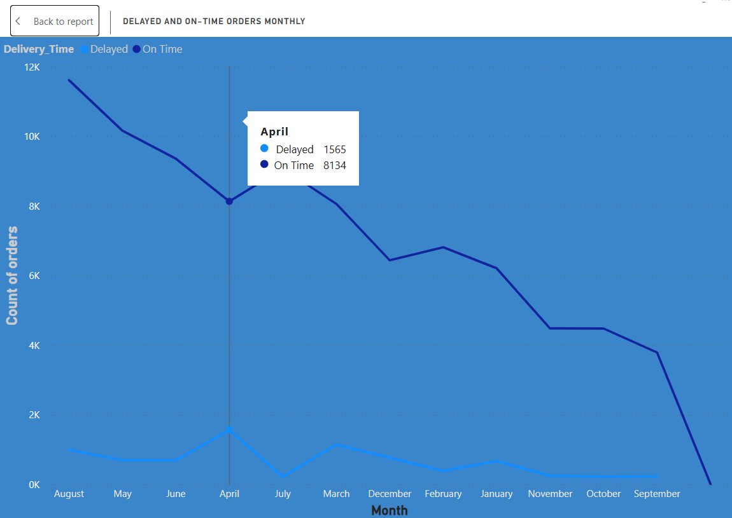Create a dynamic visual that compares the number of delayed orders to the number of orders received earlier for each month.

I took the line chart, because we can easily see and compare the Delayed and OnTime orders.

From the visualization, it is evident that:

1)The maximum number of delayed orders occurs in the month of April.

2)The highest number of orders received is observed in the month of August.

3)Subsequently, there is a declining trend in the number of orders received after August.

**Payment Method Analysis:**

Analyze the most frequently used payment methods by customers using a visually appealing representation, such as a pie chart or other suitable visuals.

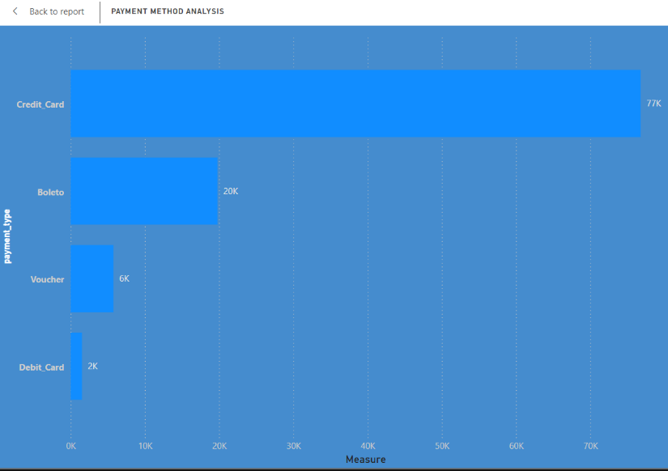

The peak in credit card usage can be attributed to the availability of no-cost EMIs offered by many credit card companies, providing customers with flexible payment options over certain months. This strategy likely contributes to the increased preference for credit card transactions among customers.

**Product Rating Analysis:**

Determine the top 10 highest-rated products and the bottom 10 lowest-rated products using a bar or column chart.

These ratings provide valuable insights into customer satisfaction levels across different product categories, helping businesses identify areas for improvement and better understand consumer preferences

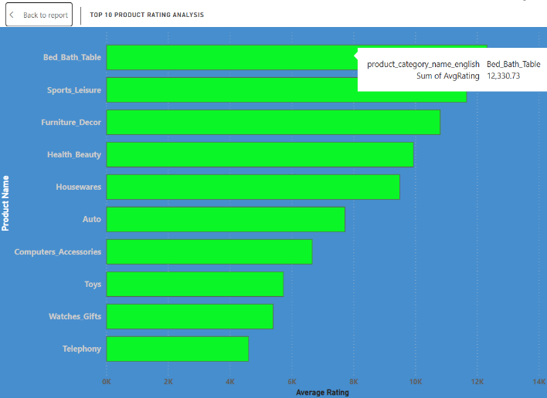**State-wise Sales Analysis:**

Identify and visually represent states with high and low sales, providing a clear understanding of regional sales performance.

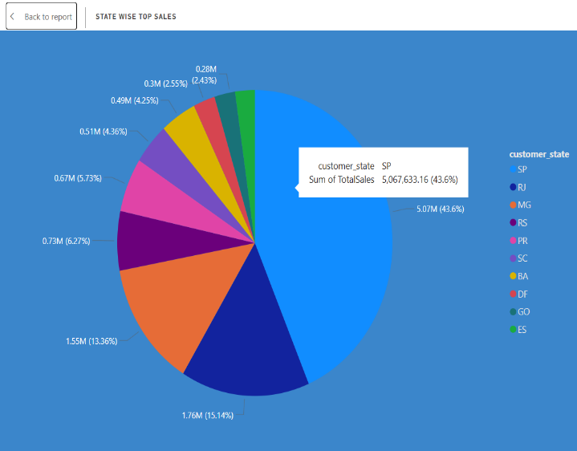

From the data, it is evident that:

1)The state with the highest sales is São Paulo (SP), with sales totaling 5 million.

2)Conversely, the state with the lowest sales is Roraima (RR), with sales amounting to 7 thousand.

This analysis offers a clear understanding of regional sales trends, enabling businesses to identify areas of strength and opportunities for growth in various geographical regions.

**Seasonal Sales Patterns:**

Investigate and visualize any seasonal patterns(Quarterly) or trends in sales data over the course of the year.

The following graphs provide insights into the seasonal patterns and trends in sales data over the course of the year.

These insights into seasonal patterns and trends in sales data offer valuable information for businesses to optimize their strategies, allocate resources effectively, and capitalize on peak sales periods throughout the year.

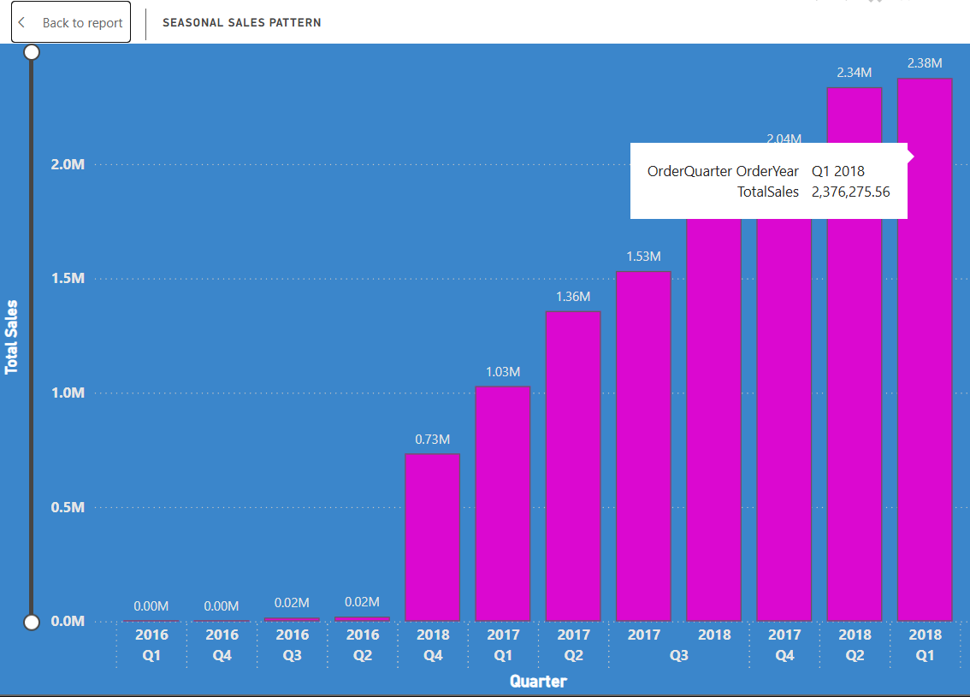

**Yearly Sales Trend:**

1) From the yearly sales trend analysis.

2) There is an overall increasing trend in sales over the years.

3) The year 2018 stands out with the maximum sales.

**Revenue Analysis:**

Determine the total revenue generated by ShopNest Store  and analyze how it changes over time(Yearly). Represent this information through suitable visuals to highlight trends and patterns.

From the analysis of the revenue trend:

1)The year 2018 stands out with the maximum revenue generation, indicating a high number of sales during that period.

2)There is a noticeable rapid increase in revenue from 2016 to 2017, suggesting significant growth during that period.

3)Subsequently, from 2017 to 2018, while the revenue continues to increase, the rate of growth appears to be more gradual.

This analysis provides valuable insights into the financial performance of ShopNest Store over the years, highlighting periods of rapid growth and identifying trends in revenue generation. Such information is crucial for strategic planning and decision-making within the organization.